SUPPLY CHAIN

MANAGEMENT

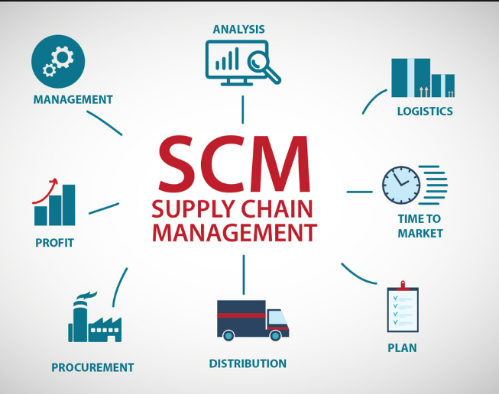

# . Supply chain management (SCM) manages the flow of goods and services, including all processes that transform raw materials into final products. It is the alignment of firms, bringing products and services to market. It is a global network that delivers products and services from raw materials to end customers through an engineered flow of information, physical distribution and cash.

# The supply chain includes the manufacturers, warehouses, suppliers, transporters, retailers, and customers themselves. It is a network of facilities and options of distribution that performs the functions of materials procurement, transforming this material into finished products and then distributing it to customers.

|  |
| --- |
| Basic Supply Chain  **The entities involved in the supply chain include :**  Producer  **Producers or manufacturers are organizations that make a product. This includes companies that are producers of raw materials and companies that are producers of finished goods.** |

* Producers of raw materials ( mining for minerals, drilling for oil and gas, and cutting timber).
* Creating intangible items such as entertainment, music, designs or software.
* Creating intangible items such as entertainment, music, designs or software.



Distributors are also known as wholesalers. They sell products in bulk. They basically buffer the fluctuations for producers by stocking inventory and doing sales work to service customers.

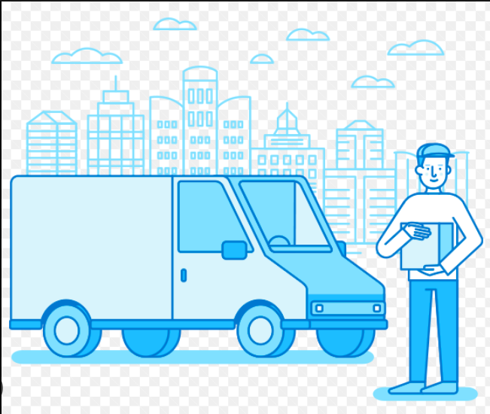

* Takes ownership of inventories for selling products to consumers
* Taking inventory in bulk and delivering a bundle of related products to the customers
* Fulfil the “Time and Place” function for the customer
* Inventory management, product transportation and warehouse operations

Retailers

Retailers basically stock inventory and sell in smaller quantities to the general public. This organization closely tracks the and demands preferences of the customers. It advertises and uses a combination of price, product selection, convenience and service as a primary draw to attract customers for selling products.

Customers

A customer is the final end-user of a product. Consumers are any organization that uses purchases the product. Customer organization purchase to incorporate the product into another one

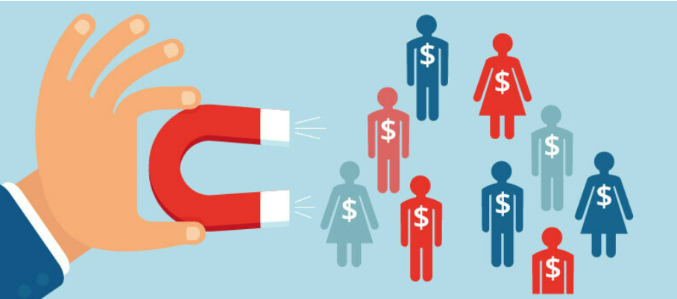

Service Providers

These organizations provide services to producers, retailers, distributors, and customers. These have developed special expertise that focuses on a particular activity needed by the supply chain.

Service providers are able to perform services at a better price than producers, distributors, retailers, or consumers more effectively. Common service providers in the supply chain are providers of warehousing services and transportation services. These are known as logistics providers (e.g., trucking companies and public warehouse companies). Financial service providers deliver services, i.e., doing credit analysis, collecting on past invoices and making loans. These are credit rating companies, banks, and collection agencies.



Types of strategies

There are three types of supply chain strategies:

* Stable supply chain strategy:

It is related to the chains focused on cost performance, execution and efficiencies. They use connectivity technologies and have less time for real-time information.

* Reactive supply chain strategy:

It works when the chain acts in fulfilling demand from the trade partners.

* Efficient reactive supply chain strategy:

It focuses on cost management and efficiency on the total delivered cost of finished goods.

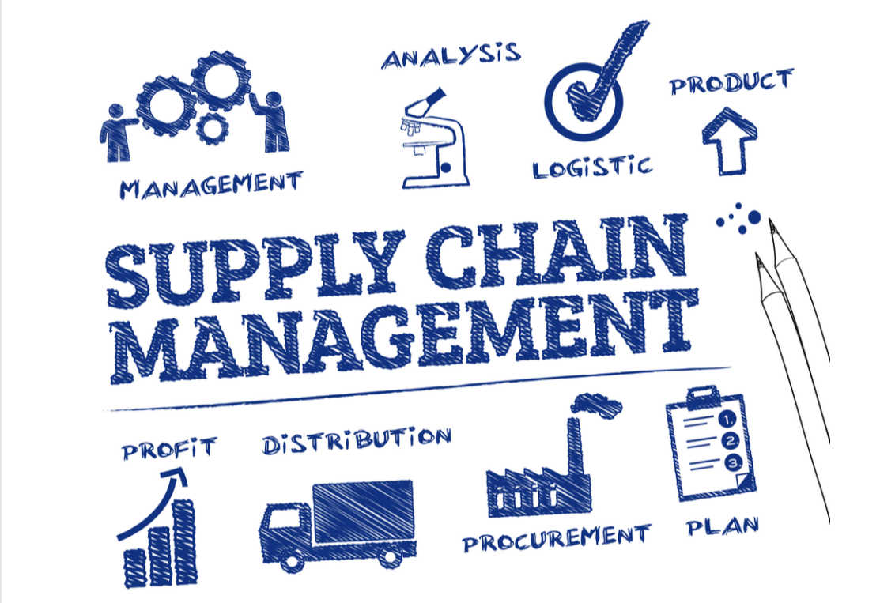

Importance of Supply Chain Management:

Supply chain management performance directly affects the organization’s overall performance.

It aids a business in gaining an advantage by delivering products in a time when done effectively. Following are the ways in which SCM benefits the company or business



* Gaining long term loyalty of happy customers
* Improving the efficiency of business
* Fast service and satisfaction of customers
* Increase revenues and higher profits
* On-time delivery of products without the inconvenience
* Increased cash flow
* Reduces company’s operating expenses
* Lowers the cost of business
* helps balance the product supply with market demand